Study of tungsten shielding around the target to limit background rates and radiation dose in the CLAS12 BST

V. Burkert, Y. Gotra, M. Ungaro

*Jefferson Lab, 12000 Jefferson Avenue, 23606 Newport News, VA, USA*

**Abstract**

Simulations of beam-related background were performed for several thicknesses of tungsten shielding cylinders around the CLAS12 target. Rates, fluences, radiation doses and 1 MeV neutron damage rates in the Barrel Silicon Tracker (BST) were calculated. The geometry includes the latest engineering models of the target and the clas12 solenoid magnetic field at full strength. The rates are also compared to calculations made in 2008-2012 for various BST hardware reviews. Tracker performance with shieling was simulated. Simulated rates are compared with experimental data after the tungsten shield has been installed.

**Simulated Detector, Beam and Target Configuration**

This simulation study is based on CLAS12 standard configuration. The Moller cone geometry corresponds to the final engineering design [1], [2], [3]. The target, shielding and vacuum beamline geometry were incorporated in Geant-4 directly from the engineering CAD models.

For each event, 124,000 electrons going through the target within a 248.5-ns time window were simulated. This corresponds to the full CLAS12 1035 cm-2s-1 luminosity on a 5cm liquid hydrogen target. Simulations were performed for a 10.6 GeV beam energy.

The nominal three layers of BST were simulated in seven geometry variations: one without shielding and the remaining with a tungsten cylinder wrapping the CLAS12 target scattering chamber with thickness ranging from 50 to 500 microns, see Figure 1.

The length of the cylinder was chosen to cover the first BST layer length.

The rates, fluences and radiation doses on the various layers of the BST were extracted for several particles. The 1 MeV neutron equivalent rates were also calculated.

The rates were calculated for four BST thresholds: 0, 15, 30 and 40 keV, see also Figure 7 for the energy deposited spectrum.

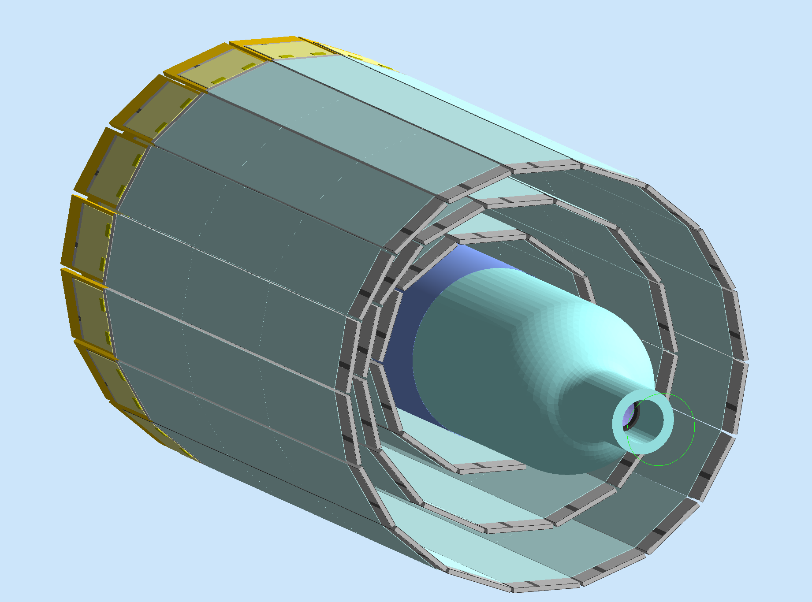

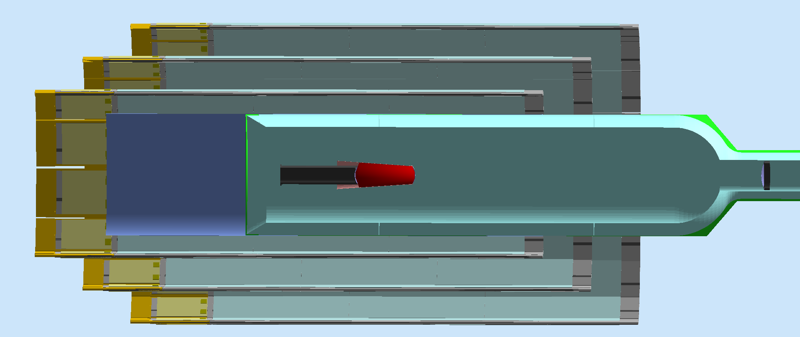

Figure 1 One of the seven geometry variations, the “thick100” configuration has a 100-micron tungsten cylinder wrapped around the CLAS12 target scattering chambers. The length of the cylinder was chosen to cover the first BST layer length.

**Rates for different particles, thresholds and tungsten thicknesses**

In *Figures 2* *- 4* the rates for different particles and all tungsten thicknesses are shown for zero, 15 keV, and 30 keV threshold respectively. In Figure 5 the rates are also compared with calculations made in 2012. The rates show some differences, especially for photons, probably attributed the different target geometry. It may be possible that the Geant-4 physics models modifications play a role in these differences.

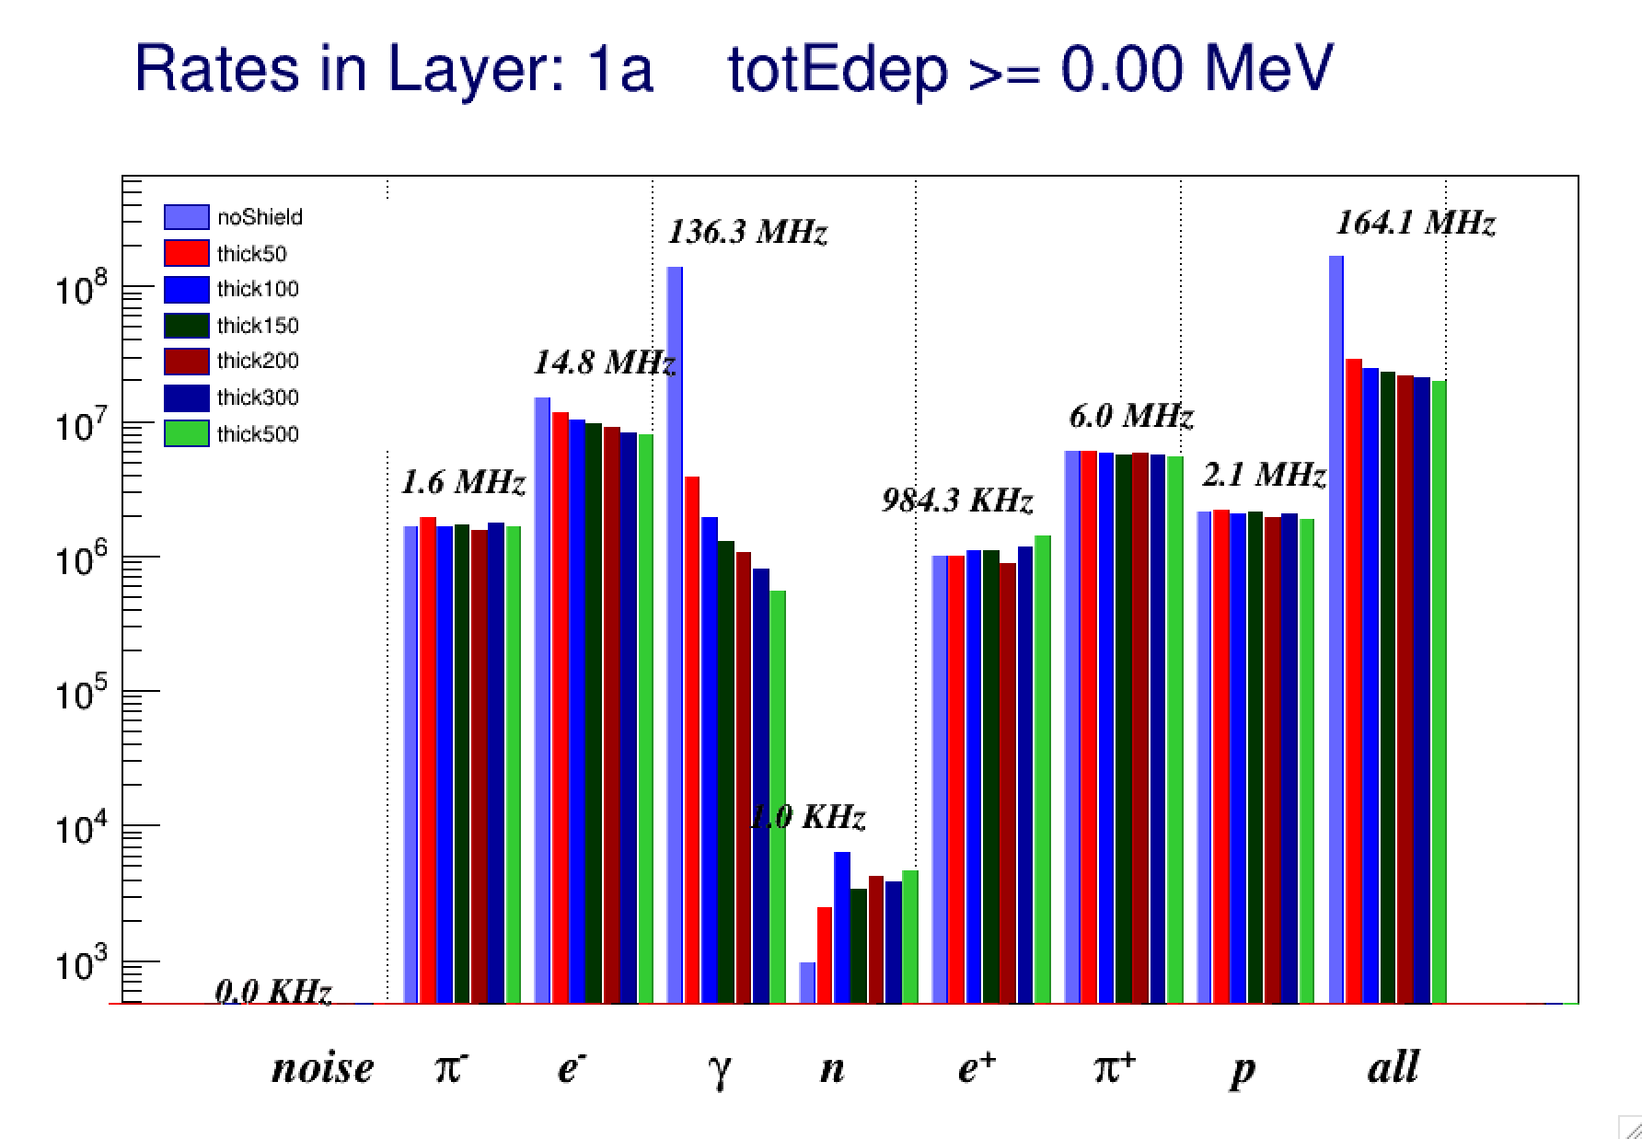

Figure 2: The rates in the first BST layer for all the shielding configurations and various particles, for no BST threshold.

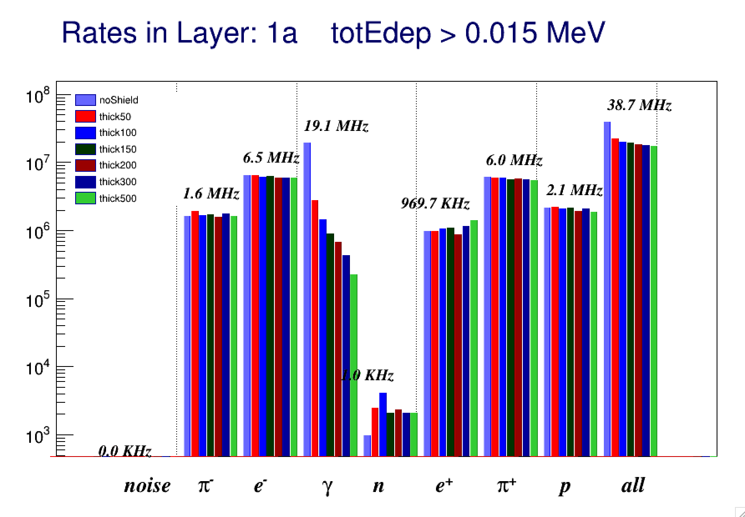

Figure 3: The rates in the first BST layer for all the shielding configurations and various particles, for a BST threshold of 15 keV.

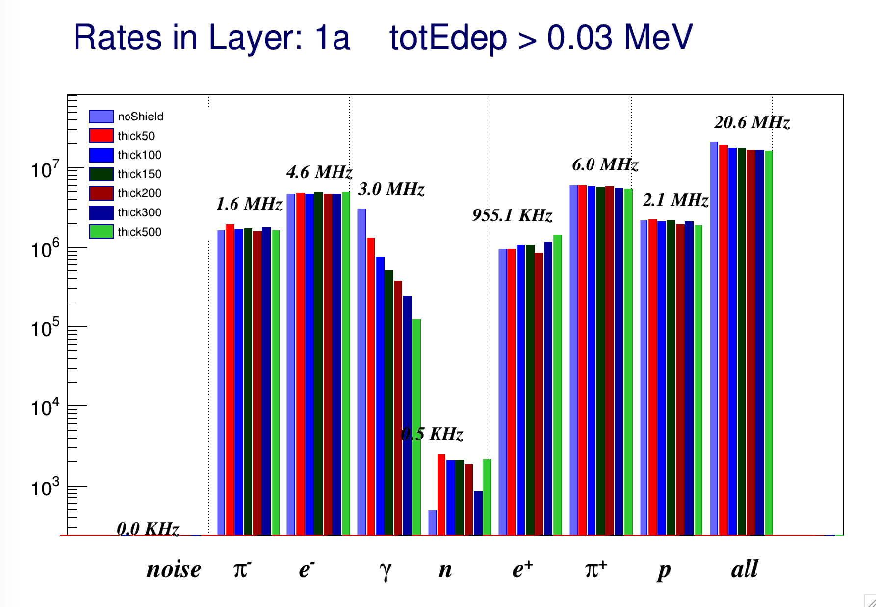

Figure 4: The rates in the first BST layer for all the shielding configurations and various particles, for a BST threshold of 30 keV.

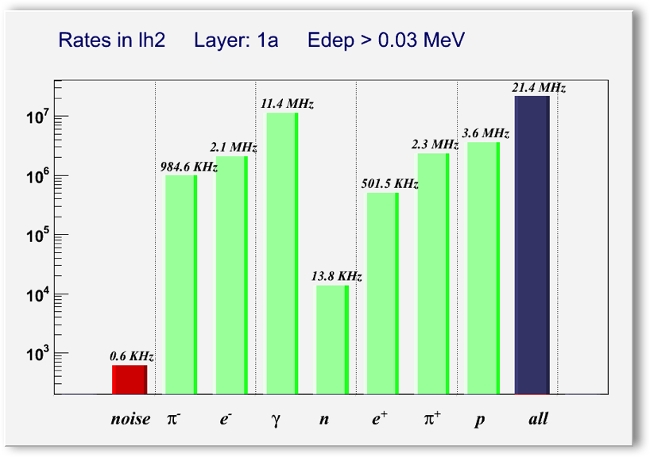

Figure 5: The rates that were calculated in 2012 for the SVT hardware review.

In Figure 6 the rates in the first layer of region 1 (layer 1A) are shown. While the electromagnetic rate is lower, the hadronic rates are similar to the ones for region 2, see Figure 7.

In Figure 8 the energy deposited in layer 1 is shown for the electromagnetic and the hadronic particles.

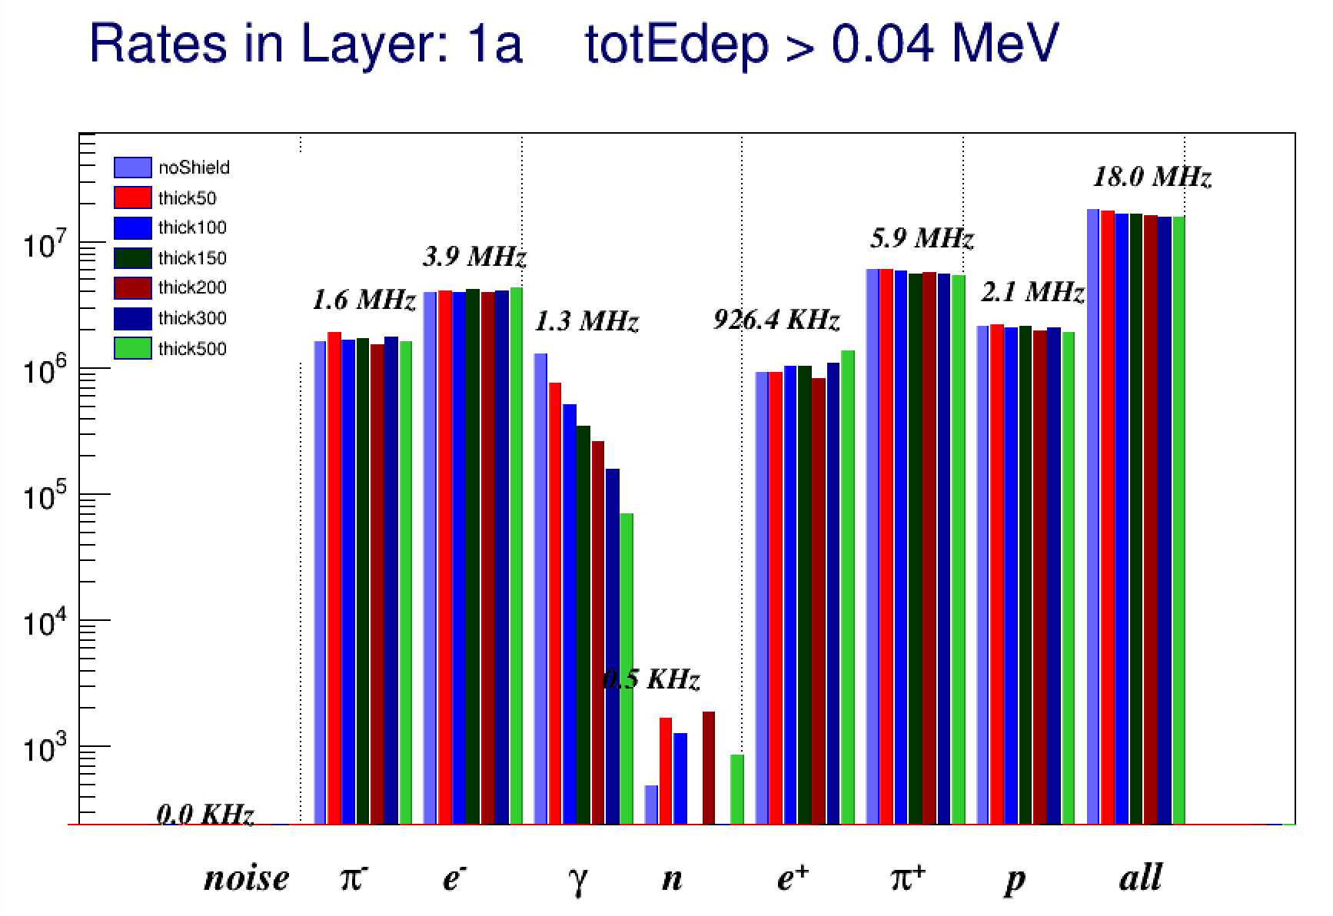

Figure 6: The rates in the first BST layer for all the shielding configurations and various particles, for a BST threshold of 40 keV.

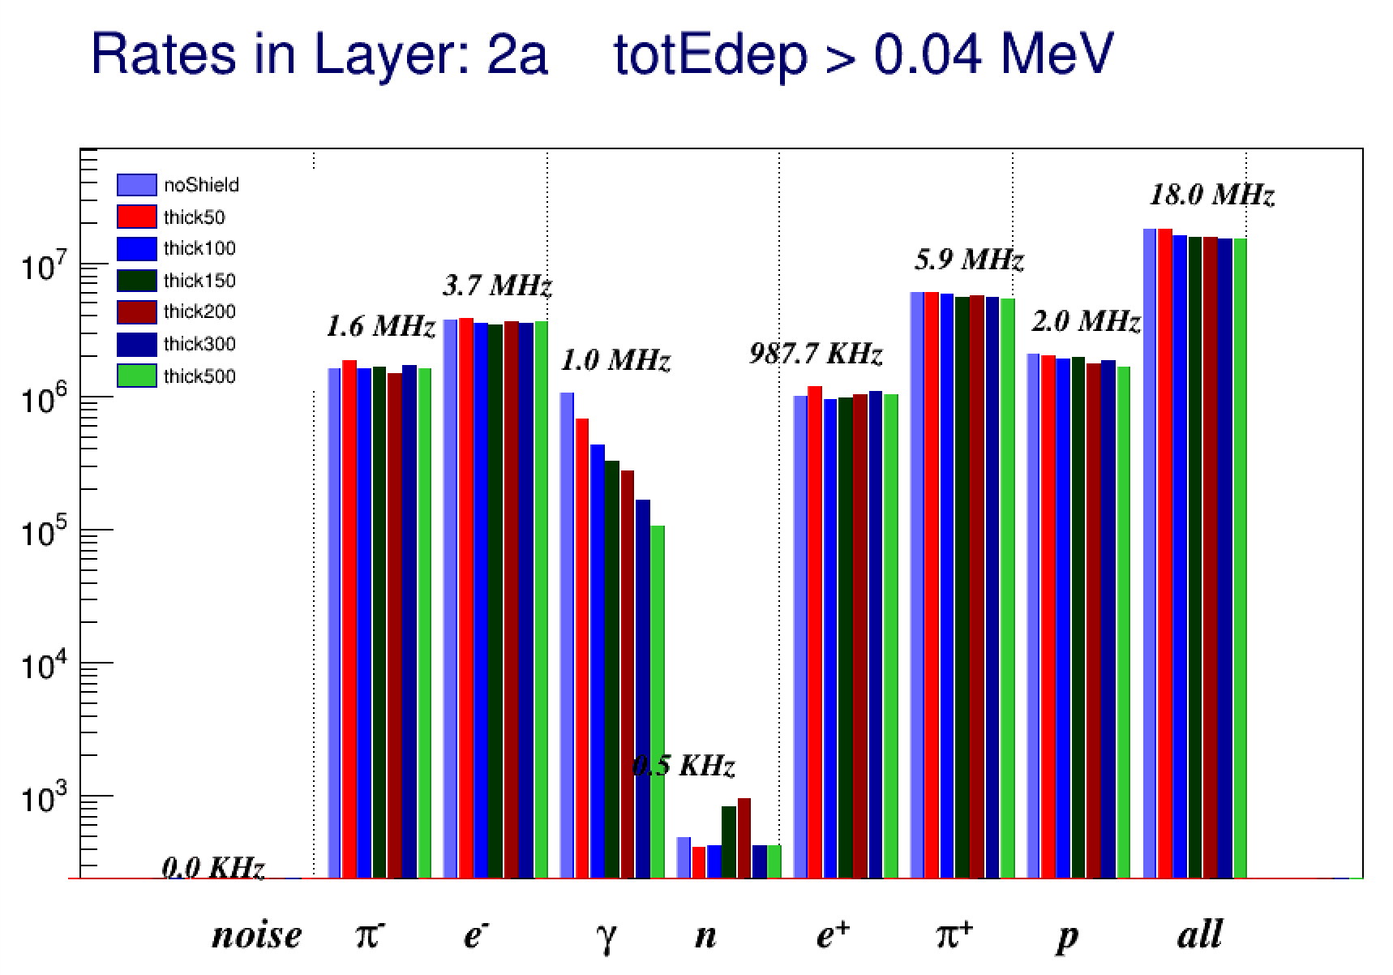

Figure 7: Rates in layer 2A for 40 keV threshold. While the electromagnetic rate is lower, the hadronic rate is similar to the one in layer 1A.

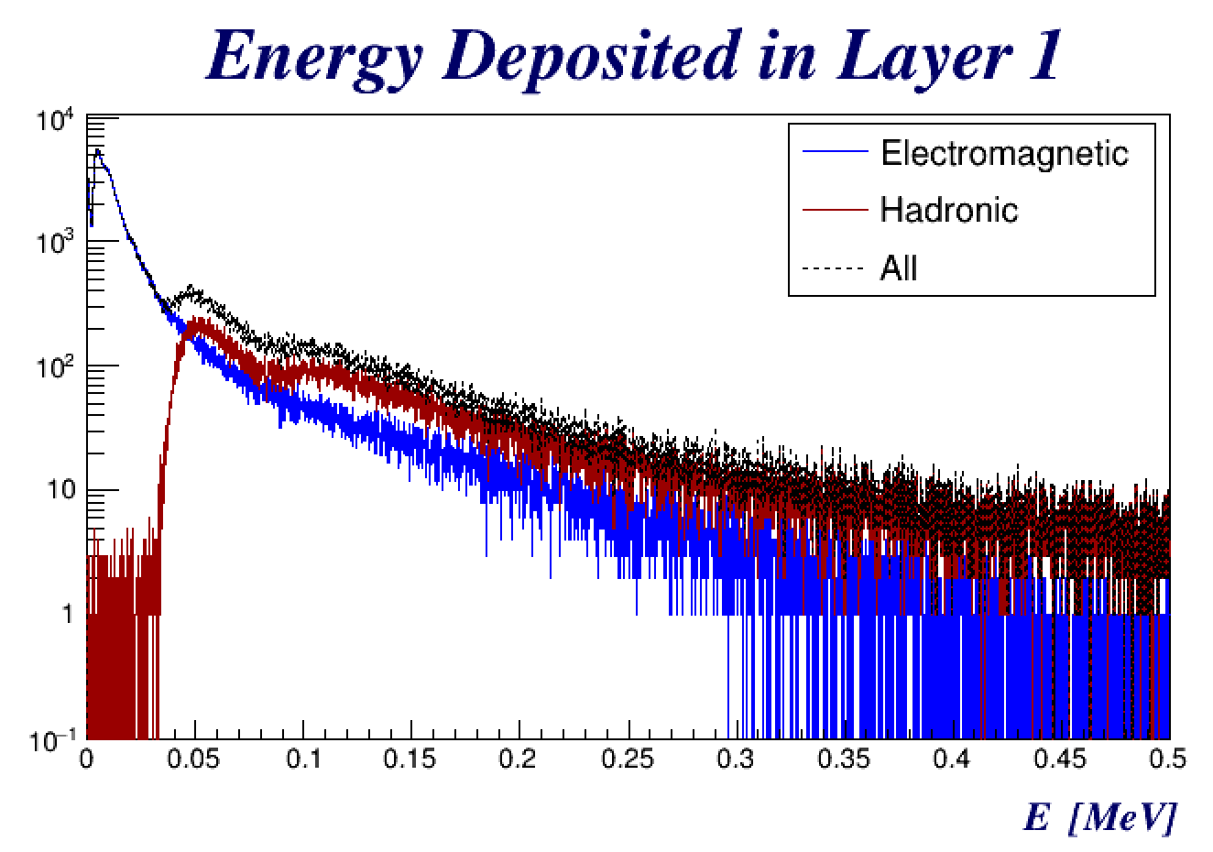

Figure 8: Energy deposited in layer 1 for electromagnetic and hadronic particles.

**Fluences**

The fluences for each particle were calculated, and the radiation doses / second and per year was extracted. The results are summarized in Tables 1 - 7 and in Figure 9. While the gamma fluences / doses show a dramatic decrease with the introduction of shielding, the total fluences and doses seems to decrease significantly for the thinner configuration and do not vary much for thicker tungsten. The photons radiation doses become negligible for 50 microns or more of tungsten. The protons and total radiation doses shows a reduction for 50 and 100 microns of tungsten but additional thickness seems to have no effect on their doses. Table 8 shows the statistics of particles in the first BST layer for the thickest shield configuration.

|  |  |  |  |
| --- | --- | --- | --- |
| **Particle** | **P, GeV/s** | **Dose rate, mrad/s** | **Dose rate, rad/y** |
| pi- | 246 | 0.12 | 3823 |
| e- | 529 | 0.26 | 8205 |
| gamma | 1288 | 0.63 | 19968 |
| n | 0 | 1.9e-5 | 0 |
| e+ | 129 | 0.06 | 2002 |
| pi+ | 839 | 0.4 | 13013 |
| p | 1753 | 0.9 | 27180 |
| all | 5157 | 2.5 | 79950 |

Table 1 Layer 1 fluences and radiation does for configuration with no shield.

|  |  |  |  |
| --- | --- | --- | --- |
| **Particle** | **P, GeV/s** | **Dose rate, mrad/s** | **Dose rate, rad/y** |
| pi- | 306 | 0.15 | 4758 |
| e- | 533 | 0.26 | 8275 |
| gamma | 106 | 0.05 | 1653 |
| n | 3 | 0.002 | 54 |
| e+ | 116 | 0.06 | 1802 |
| pi+ | 845 | 0.41 | 13100 |
| p | 1811 | 0.89 | 28082 |
| all | 4013 | 1.97 | 62226 |

Table 2: Layer 1 fluences and radiation does for 50-micron thick tungsten shield.

|  |  |  |  |
| --- | --- | --- | --- |
| **Particle** | **P, GeV/s** | **Dose rate, mrad/s** | **Dose rate, rad/y** |
| pi- | 230 | 0.11 | 3572 |
| e- | 515 | 0.25 | 7992 |
| gamma | 60 | 0.03 | 941 |
| n | 0 | 8e-5 | 2 |
| e+ | 134 | 0.07 | 2089 |
| pi+ | 814 | 0.4 | 12624 |
| p | 1668 | 0.82 | 25864 |
| all | 3703 | 1.82 | 57414 |

Table 3: Layer 1 fluences and radiation does for 100-micron thick tungsten shield.

|  |  |  |  |
| --- | --- | --- | --- |
| **Particle** | **P, GeV/s** | **Dose rate, mrad/s** | **Dose rate, rad/y** |
| pi- | 248 | 0.12 | 3845 |
| e- | 538 | 0.26 | 8347 |
| gamma | 40 | 0.02 | 632 |
| n | 0 | 4e-5 | 1 |
| e+ | 127 | 0.06 | 1974 |
| pi+ | 756 | 0.37 | 11722 |
| p | 1775 | 0.87 | 27521 |
| all | 3742 | 1.84 | 58018 |

Table 4: Layer 1 fluences and radiation does for 150-micron thick tungsten shield.

|  |  |  |  |
| --- | --- | --- | --- |
| **Particle** | **P, GeV/s** | **Dose rate, mrad/s** | **Dose rate, rad/y** |
| pi- | 227 | 0.11 | 3529 |
| e- | 497 | 0.24 | 7720 |
| gamma | 31 | 0.016 | 494 |
| n | 0 | 8e-5 | 2 |
| e+ | 106 | 0.05 | 1646 |
| pi+ | 764 | 0.4 | 11858 |
| p | 1629 | 0.8 | 25253 |
| all | 3510 | 1.73 | 54426 |

Table 5: Layer 1 fluences and radiation does for 200-micron thick tungsten shield.

|  |  |  |  |  |
| --- | --- | --- | --- | --- |
| **Particle** | **P, GeV/s** | **Dose rate, mrad/s** | **Dose rate, rad/y** | |
| pi- | 257 | 0.13 | 3984 |
| e- | 508 | 0.25 | 7878 |
| gamma | 21 | 0.01 | 332 |
| n | 0 | 4e-5 | 1 |
| e+ | 140 | 0.07 | 2179 |
| pi+ | 747 | 0.4 | 11584 |
| p | 1747 | 0.86 | 27097 |
| all | 3643 | 1.79 | 56488 |

Table 6: Layer 1 fluences and radiation does for 300-micron thick tungsten shield.

|  |  |  |  |
| --- | --- | --- | --- |
| **Particle** | **P, GeV/s** | **Dose rate, mrad/s** | **Dose rate, rad/y** |
| pi- | 240 | 0.12 | 3534 |
| e- | 533 | 0.26 | 8274 |
| gamma | 11 | 0.006 | 185 |
| n | 0 | 5e-5 | 1 |
| e+ | 165 | 0.08 | 2573 |
| pi+ | 740 | 0.4 | 11485 |
| p | 1612 | 0.79 | 24990 |
| all | 3502 | 1.72 | 54296 |

Table 7: Layer 1 fluences and radiation does for 500-micron thick tungsten shield.

|  |  |
| --- | --- |
| **Particle** | **Number of particles** |
| pi- | 3885 |
| e- | 18793 |
| gamma | 1287 |
| n | 11 |
| e+ | 3344 |
| pi+ | 12757 |
| p | 4467 |

Table 8: the number of particles in layer 1 for the thickest (500 microns) shield configuration.

Figure 9: Radiation doses for gammas, protons and total as a function of tungsten thickness.

**One MeV Neutron Damage Rates**

The damage to silicon is estimated using one MeV Neutron Damage rates [4]. The damage from electrons, pions and protons is converted as a function of momentum using the tables reported in the appendix.

The damage rates are reported in Tables 9 - 15.

|  |  |  |
| --- | --- | --- |
| **Particle** | **Rate, MHz** | **1 MeV n equivalent rate, MHz** |
| e- | 16.5 | 0.12 |
| pions | 1.5 | 1.1 |
| neutrons | 9e-4 | 0.002 |
| protons | 2.1 | 14.6 |
| total | 20 | 15.8 |

Table 9: 1 MeV Neutron Damage Rate (MHz) for no shield.

|  |  |  |
| --- | --- | --- |
| **Particle** | **Rate, MHz** | **1 MeV n equivalent rate, MHz** |
| e- | 13.1 | 0.12 |
| pions | 1.83 | 1.3 |
| neutrons | 0.003 | 0.003 |
| protons | 2.2 | 15 |
| total | 17 | 16 |

Table 10: 1 MeV Neutron Damage Rate (MHz) for 50 microns shield.

|  |  |  |
| --- | --- | --- |
| **Particle** | **Rate, MHz** | **1 MeV n equivalent rate, MHz** |
| e- | 12 | 0.12 |
| pions | 1.6 | 1.1 |
| neutrons | 0.007 | 0.006 |
| protons | 2.1 | 14 |
| total | 15 | 15 |

Table 11: 1 MeV Neutron Damage Rate (MHz) for 100 microns shield.

|  |  |  |
| --- | --- | --- |
| **Particle** | **Rate, MHz** | **1 MeV n equivalent rate, MHz** |
| e- | 11 | 0.12 |
| pions | 1.6 | 1.2 |
| neutrons | 0.003 | 0.003 |
| protons | 2.1 | 14.5 |
| total | 15 | 15.7 |

Table 12: 1 MeV Neutron Damage Rate (MHz) for 150 microns shield.

|  |  |  |
| --- | --- | --- |
| **Particle** | **Rate, MHz** | **1 MeV n equivalent rate, MHz** |
| e- | 10.3 | 0.11 |
| pions | 1.5 | 1.1 |
| neutrons | 0.004 | 0.004 |
| protons | 1.95 | 13.2 |
| total | 14 | 14.4 |

Table 13: MeV Neutron Damage Rate (MHz) for 200 microns shield.

|  |  |  |
| --- | --- | --- |
| **Particle** | **Rate, MHz** | **1 MeV n equivalent rate, MHz** |
| e- | 9.7 | 0.12 |
| pions | 1.7 | 1.2 |
| neutrons | 0.004 | 0.005 |
| protons | 2.1 | 14 |
| total | 13.5 | 15 |

Table 14: 1 MeV Neutron Damage Rate (MHz) for 300 microns shield.

|  |  |  |
| --- | --- | --- |
| **Particle** | **Rate, MHz** | **1 MeV n equivalent rate, MHz** |
| e- | 9.4 | 0.14 |
| pions | 1.6 | 1.1 |
| neutrons | 0.005 | 0.004 |
| protons | 1.9 | 12 |
| total | 13 | 14 |

Table 15: 1 MeV Neutron Damage Rate (MHz) for 500 microns shield.

Effect of the tungsten shield on tracking performance was studied using MC simulation with 50 μm shield configuration. The results are presented in Figures 10 and 11. The effect of the shield on tracking performance (momentum, angular, and vertex resolutions and mean bias) are negligible.



Figure 10: Tracking performance for the configuration without shield. Top row – resolutions for momentum, azimuthal and polar angle, and Z coordinate of the vertex. Bottom row – corresponding mean of the difference between the generated and reconstructed values.



Figure 11: Tracking performance for the 50 μm shield configuration. Top row – resolutions for momentum, azimuthal and polar angle, and Z coordinate of the vertex. Bottom row – corresponding mean of the difference between the generated and reconstructed values.

**Comparison with physics run data: full field, lH2 target**

A tungsten shield 51 μm thick has been installed on the target scattering chamber. The shield consists of 2 sheets mounted over the top and bottom halves of the foam cylinder. Originally there was a 2-inch overlap of the shield over the metal support tube. The shield was grounded through the metal tube. Due to the noise from the CAEN mainframes picked up by the shield and induced on the SVT front-end electronics, this configuration has been modified. The two parts of the shield were insulated from the scattering chamber metal support tube and mounted with no overlap. Each sheet was grounded with a separate 18-gauge copper wire up to the gap between the BST support tube and the support tube of the scattering chamber support tube. There the gap is larger and 12-gauge grounding wires are used. Both wires are connected together at the exit from the BST support tube and are referenced to the BST common ground. Such configuration allowed reducing the coherent noise from the CAEN mainframes to a manageable level.

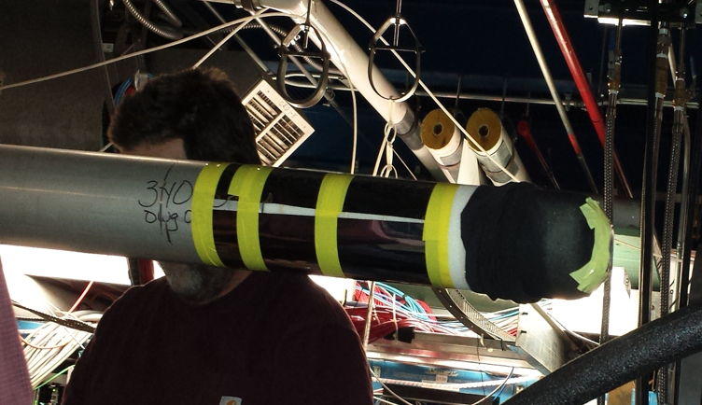

Figure 12: Installation of the tungsten shield on the scattering chamber.

The BST scaler hit rates after shield installation are presented in the Figure 13. There are higher rates in some layer 1 and layer 2 sensors because of the operating conditions requiring to lower the sensor bias voltage due to higher leakage currents.

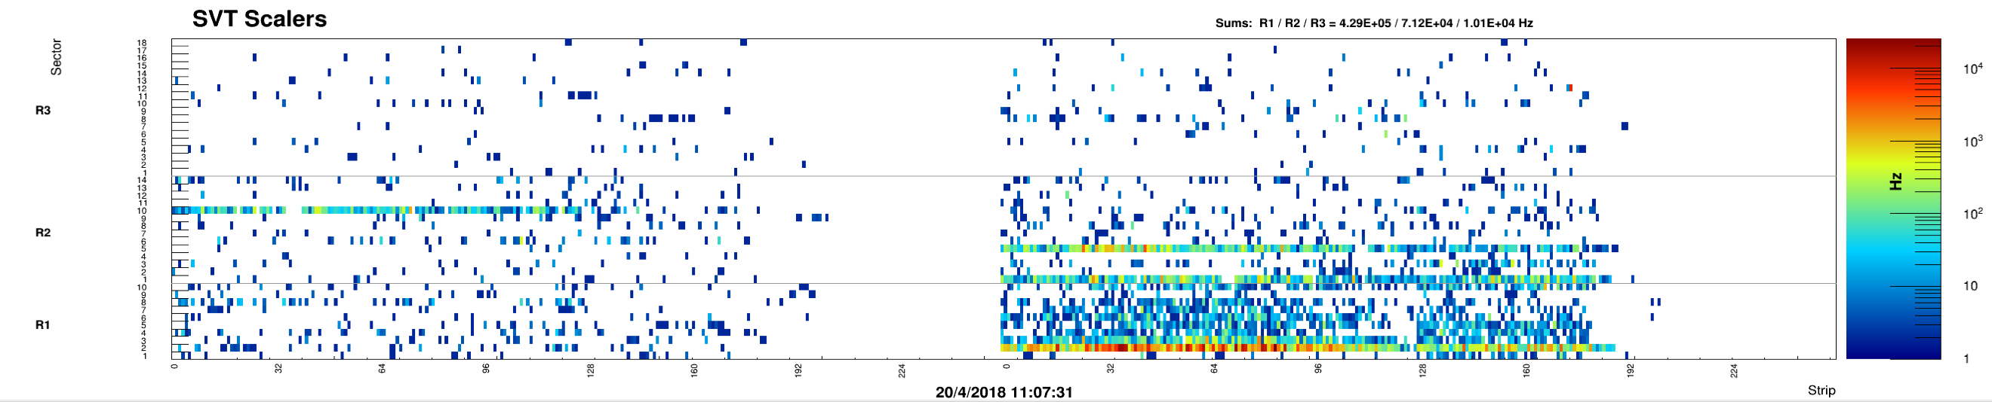

Figure 13: BST scaler hit rates after installation of the tungsten shield. Left – top side of the module, right – bottom side.

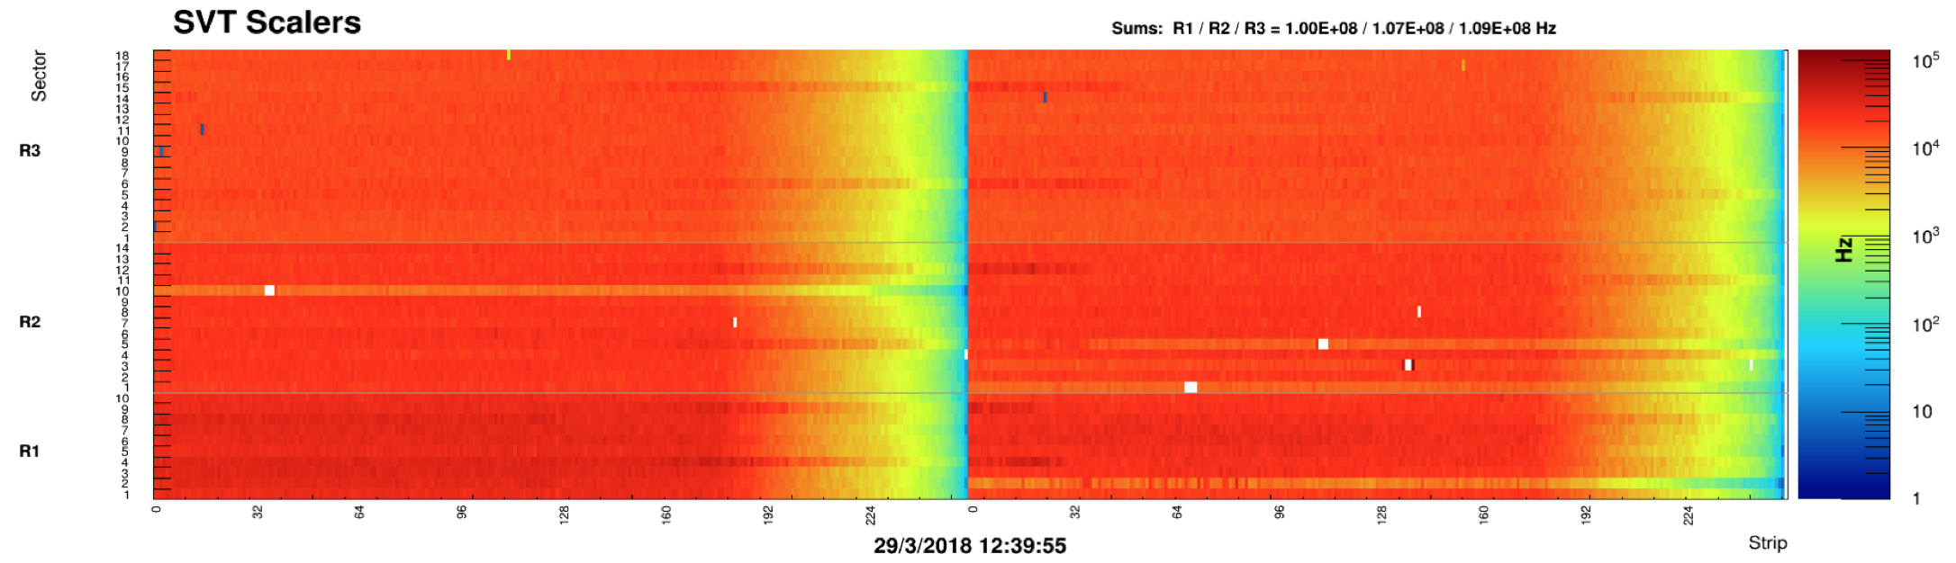

Figure 14 BST scaler hit rates with 75 nA beam current. Left – top side of the module, right – bottom side.

In Figure 15 are presented the BST scaler hit occupancies for the run taken at design luminosity (75 nA beam current). Overall hit map is uniform with lower occupancies towards the high strip number where the strips have shorter length. The white rectangles correspond to the masked channels with high occupancy. In these sensors the leakage current is higher and the sensor bias was reduced to ensure stable operation.

The impact of the shield on the BST occupancy is shown in Figure 15. Occupancies in all BST layers are substantially lower which results in better tracking performance due to reduced combinatorics.

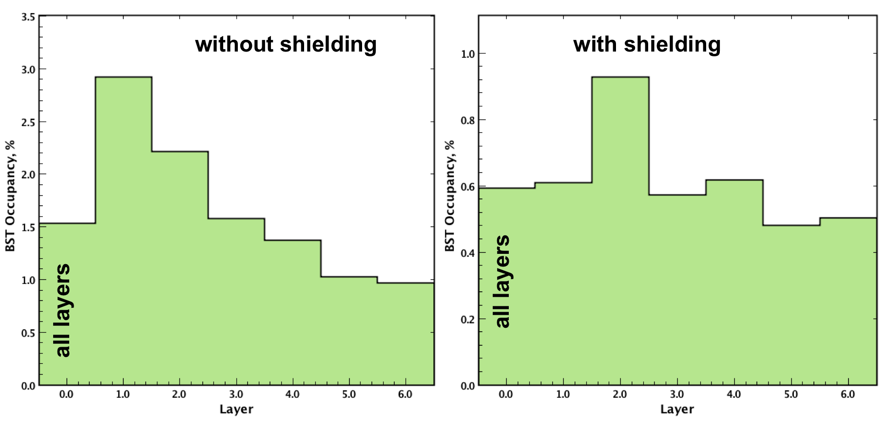

Figure 15: BST hit occupancies with and without 51 μm shield.

The hit rates on the BST layers have been extracted for several runs with different current, time windows and thresholds, see Table 16.

|  |  |  |  |  |  |  |  |  |
| --- | --- | --- | --- | --- | --- | --- | --- | --- |
| Run | Current | L1 | L2 | L3 | L4 | L5 | L6 | Total |
| 3767 | 5 | 3.5 | 4.9 | 4.4 | 4.5 | 4.4 | 4.7 | 26.2 |
| 3786 | 10 | 7.6 | 10.1 | 9.1 | 9.3 | 9.0 | 9.3 | 54.0 |
| 3770 | 35 | 24.1 | 34.9 | 29.8 | 31.8 | 31.0 | 32.8 | 182.1 |
| 3771 | 50 | 33.7 | 48.6 | 42.2 | 44.6 | 43.9 | 45.7 | 253.5 |
| 3779 | 75 | 52.9 | 72.8 | 65.5 | 68.5 | 65.9 | 69.5 | 393.2 |

Table 16: Rates in MHz for the BST layers. Runs taken at different beam current, 512 ns time window and 30 keV threshold (except for the layer 1, 32.5 keV).

The simulated rates at full luminosity for 30 keV threshold are shown in Table 17. To compare the simulated rates with results taken at 75 nA beam current the difference in the BST DAQ window size should be taken into account. The data were taken with a 512-ns window while the simulation was done with 248.5 ns window. In Figure 16 the BST trigger latency plot is shown. The window size is set to 4 Bunch Cross Oscillator (BCO) cycles. Each cycle is 128 ns. Preamplifier shaping time is 125 ns with “low gain” setting. There are 5 bins in this distribution. One extra bin corresponds to the case when the hit went to an adjacent BCO cycle as expected. More precise time stamp of the hit can be obtained by using the GotHit timing. This would require re-programming the firmware of the BST readout boards. As can be seen from this plot, the signal is well fit within the window. After scaling the rates there is a good agreement between the experimental data and the simulation.

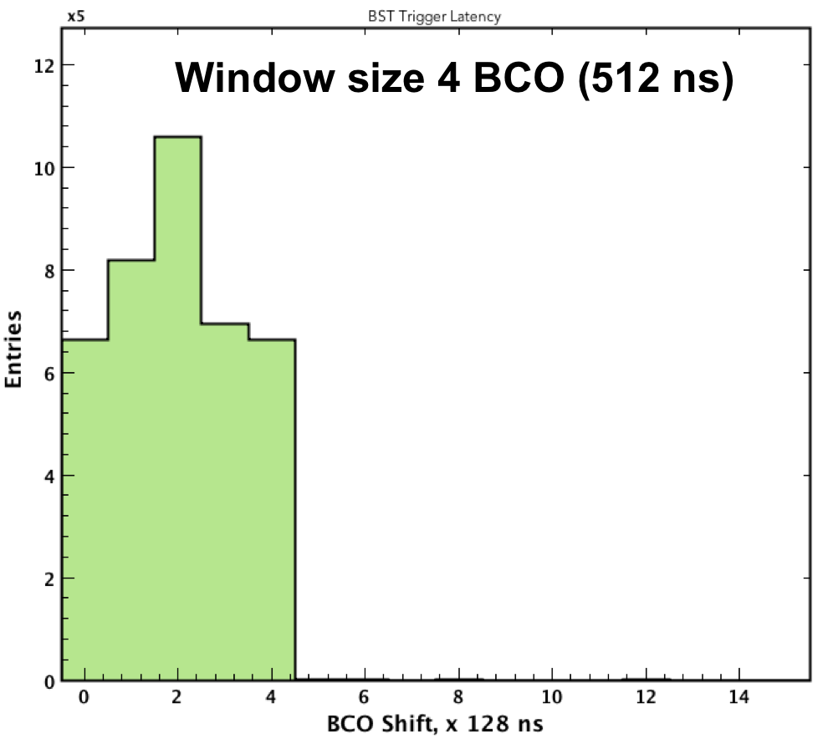

Figure 16 BST trigger latency.

|  |  |  |  |
| --- | --- | --- | --- |
| Layer | E.M | Hadronic | Total |
| 1 | 10.5 | 12.0 | 22.6 |
| 2 | 9.4 | 11.3 | 20.6 |
| 3 | 9.1 | 12.4 | 21.5 |
| 4 | 9.0 | 11.6 | 20.6 |
| 5 | 7.6 | 11.9 | 19.5 |
| 6 | 8.2 | 11.4 | 19.6 |

Table 17: Rates in MHz for simulation at full luminosity for 26 keV threshold.

**Simulations at 51 m**

GEMC simulations were run again with the correct thickness of 51 m. The max step length in the active silicon volumes were reduced by a factor of 10 to improve the accuracy of the digitization positions. In addition, several geometry / configuration / code changes were implemented from version 4a.2.2 to 4a.2.5 [5]. Finally, the geant4 version was upgraded.

Two configurations were run: no BST shield and 51 m tungsten shield. While the electron rates increased (due to forcing geant4 to have more steps inside the silicon) their overall deposited energy did not vary substantially from what was simulated originally, and the total 1 MeV Neutron Damage Rate is virtually unchanged as is the rate reduction of photons.

The new fluences are summarized in tables 18 and 19, while the total damage rates are summarized in tables 20 and 21 for no shield and 51 m shield respectively.

|  |  |  |  |  |
| --- | --- | --- | --- | --- |
| **Particle** | **P, GeV/s** | **Dose rate, mrad/s** | **Dose rate, rad/y** | |
| pi- | 242 | 0.119389 | 3765 |
| e- | 3668 | 1.80315 | 56864 |
| gamma | 1800 | 0.885341 | 27920 |
| n | 33 | 0.0164856 | 519 |
| e+ | 101 | 0.049851 | 1572 |
| pi+ | 688 | 0.33855 | 10676 |
| p | 1338 | 0.658019 | 20751 |
| all | 4120 | 2.02578 | 63885 |

Table 18: Layer 1 fluences and radiation does for no shield.

|  |  |  |  |
| --- | --- | --- | --- |
| **Particle** | **P, GeV/s** | **Dose rate, mrad/s** | **Dose rate, rad/y** |
| pi- | 206 | 0.101429 | 3198 |
| e- | 2444 | 1.20172 | 37897 |
| gamma | 592 | 0.291399 | 9189 |
| n | 44 | 0.0217787 | 686 |
| e+ | 122 | 0.0602238 | 1899 |
| pi+ | 678 | 0.333713 | 10523 |
| p | 1342 | 0.660112 | 20817 |
| all | 2885 | 1.41863 | 44737 |

Table 19: Layer 1 fluences and radiation does for 51-micron thick tungsten shield.

|  |  |  |
| --- | --- | --- |
| **Particle** | **Rate, MHz** | **1 MeV n equivalent rate, MHz** |
| e- | 161.57 | 0.74 |
| pions | 1.53 | 0.98 |
| neutrons | 0.04 | 0.04 |
| protons | 2.07 | 13.31 |
| Total: | 165.21 | 15.06 |

Table 20: 1 MeV Neutron Damage Rate (MHz) for no shield.

|  |  |  |
| --- | --- | --- |
| **Particle** | **Rate, MHz** | **1 MeV n equivalent rate, MHz** |
| e- | 17.67 | 0.30 |
| pions | 1.48 | 0.96 |
| neutrons | 0.04 | 0.03 |
| protons | 2.04 | 13.04 |
| Total: | 21.22 | 14.34 |

Table21: 1 MeV Neutron Damage Rate (MHz) for 51 microns shield.

**Conclusions**

Both the rates and the radiation damage benefit from 51 microns of tungsten shield around the CLAS12 scattering chambers. There is no benefit in additional thicknesses. The rates have been compared with physics run data at several beam currents. There is a good agreement between the real and the simulated data.

**References**

*[1] R. De Vita and M. Ungaro,* ***CLAS12-note 2016-006****:* Moller shield simulations: comparison of the GEMC-optimized layout and the engineering design.

*[2] M. Ungaro,* ***CLAS12-note 2017-013****:* Corrections to CLAS12 target design.

*[3] R. De Vita, D. S. Carman, C. Smith, S. Stepanyan and M. Ungaro,* ***CLAS12-note 2017-016****:* Study of the electromagnetic background rates in CLAS12.

*[4] A. Akkerman, J. Barak, M.B. Chadwick, J. Levinson, M. Murat, Y. Lifshitz,* ***Radiation Physics and Chemistry 62 (2001) 301–310****:* Updated NIEL calculations for estimating the damage induced by particles and g-rays in Si and GaAs

[5] *M. Ungaro*, clas12 simulation software / geometry tags: https://github.com/gemc/clas12Tags.

**Appendix:**

**Conversion tables for One MeV Neutron Damage Rates**

The columns are: 1: momentum bin minimum; 2: momentum bin maximum; 3: conversion factor to 1 MeV Neutron.

Neutrons:

1.025E-10 1.313E-09 8.810E-03

1.388E-09 1.850E-08 2.382E-03

1.950E-08 2.475E-07 6.449E-04

2.625E-07 3.500E-06 1.748E-04

3.700E-06 4.875E-05 4.734E-05

5.125E-05 6.450E-04 2.278E-04

6.750E-04 8.600E-03 3.418E-03

9.000E-03 1.125E-01 3.997E-02

1.175E-01 1.850E+00 7.057E-01

1.950E+00 6.950E+00 1.438E+00

7.050E+00 1.205E+01 1.753E+00

1.215E+01 1.715E+01 1.842E+00

1.725E+01 8.050E+02 1.590E+00

8.150E+02 1.315E+03 5.761E-01

1.325E+03 2.005E+03 5.436E-01

Electrons:

0.000E+00 3.000E-01 3.182E-03

3.001E-01 5.000E-01 7.998E-03

5.001E-01 7.000E-01 1.139E-02

7.001E-01 1.000E+00 1.543E-02

1.001E+00 2.000E+00 2.489E-02

2.001E+00 3.000E+00 3.126E-02

3.001E+00 5.000E+00 3.979E-02

5.001E+00 7.000E+00 4.558E-02

7.001E+00 1.000E+01 5.160E-02

1.001E+01 2.000E+01 6.241E-02

2.001E+01 3.000E+01 6.780E-02

3.001E+01 5.000E+01 7.344E-02

5.001E+01 7.000E+01 7.634E-02

7.001E+01 1.000E+02 7.870E-02

1.001E+02 2.000E+02 8.106E-02

Pions:

1.500E+01 1.550E+02 6.611E-01

1.650E+02 2.950E+02 9.090E-01

3.050E+02 4.450E+02 6.916E-01

4.550E+02 5.850E+02 5.634E-01

5.950E+02 7.250E+02 5.125E-01

7.350E+02 8.650E+02 5.506E-01

8.750E+02 1.005E+03 5.481E-01

1.015E+03 1.145E+03 5.186E-01

1.155E+03 1.285E+03 5.384E-01

1.295E+03 1.425E+03 5.374E-01

1.435E+03 1.565E+03 5.132E-01

1.575E+03 1.705E+03 4.935E-01

1.715E+03 1.845E+03 4.843E-01

1.855E+03 2.005E+03 4.806E-01

Protons:

1.001E-01 7.000E-01 6.0E+01

7.000E-01 8.500E+01 8.896E+00

9.500E+01 2.350E+02 1.076E+00

2.450E+02 3.850E+02 8.811E-01

3.950E+02 5.350E+02 7.982E-01

5.450E+02 6.850E+02 7.499E-01

6.950E+02 8.350E+02 7.192E-01

8.450E+02 9.850E+02 6.968E-01

9.950E+02 1.135E+03 6.790E-01

1.145E+03 1.285E+03 6.667E-01

1.295E+03 1.435E+03 6.552E-01

1.445E+03 1.585E+03 6.453E-01

1.595E+03 1.735E+03 6.356E-01

1.745E+03 1.885E+03 6.269E-01

1.895E+03 2.005E+03 6.204E-01